District Summary:

[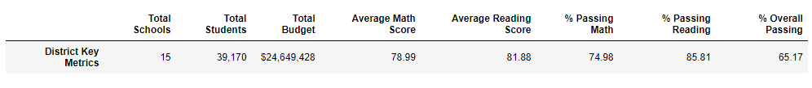](https://user-images.githubusercontent.com/142269763/268515862-4d484ea4-6fd2-48af-969b-30ec20f74e00.png)

School Types:

[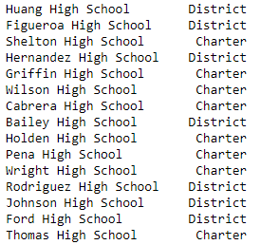](https://user-images.githubusercontent.com/142269763/268515899-8ae72ac8-3bfc-416c-86e3-7df33144cf96.png)

Students Per School Total:

[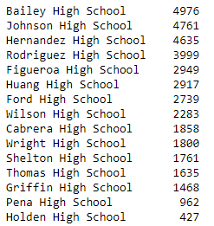](https://user-images.githubusercontent.com/142269763/268515916-c79b3bdd-dcb3-4317-a1aa-a0d44c8acb9f.png)

Budget Per School:

[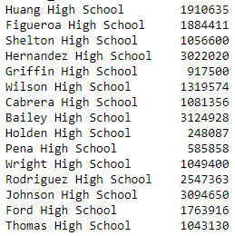](https://user-images.githubusercontent.com/142269763/268515938-e289d99d-0cf7-48d4-93ce-1ef2517afdaa.png)

Budget Per Student Per School:

[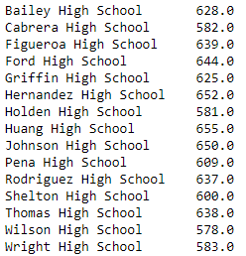](https://user-images.githubusercontent.com/142269763/268515987-364d8141-45ee-43da-959a-905839647b5b.png)

Students Per School Passing Math:

[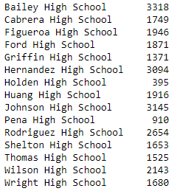](https://user-images.githubusercontent.com/142269763/268516031-4b8ce5e4-a34d-433a-af85-0c6a3d1ed074.png)

Students Per School Passing Reading:

[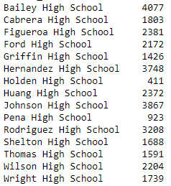](https://user-images.githubusercontent.com/142269763/268516061-3d098c7d-ea0f-478d-b826-f8971855655d.png)

Students Per School Passing Both Math and Reading:

[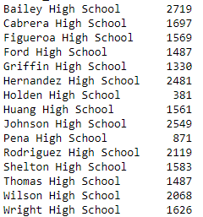](https://user-images.githubusercontent.com/142269763/268516082-0daf53e9-d2ba-417b-b7dc-b57b9129143e.png)

Students Per School Passing Math (%):

[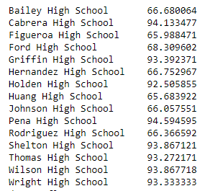](https://user-images.githubusercontent.com/142269763/268734119-4d5a9304-25f8-4349-a750-e64b6be7a6a3.png)

Students Per School Passing Reading (%):

[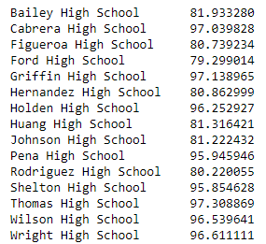](https://user-images.githubusercontent.com/142269763/268734291-0e0296a9-fcc8-4592-a52c-3fa5ca853b6e.png)

Overall Students Per School Passing Both Math and Reading (%):

[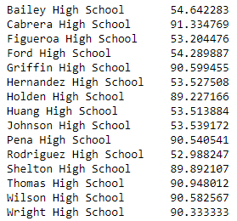](https://user-images.githubusercontent.com/142269763/268516103-12092a73-f2bb-464b-a1b6-a9aa3128561a.png)

Per School Summary:

[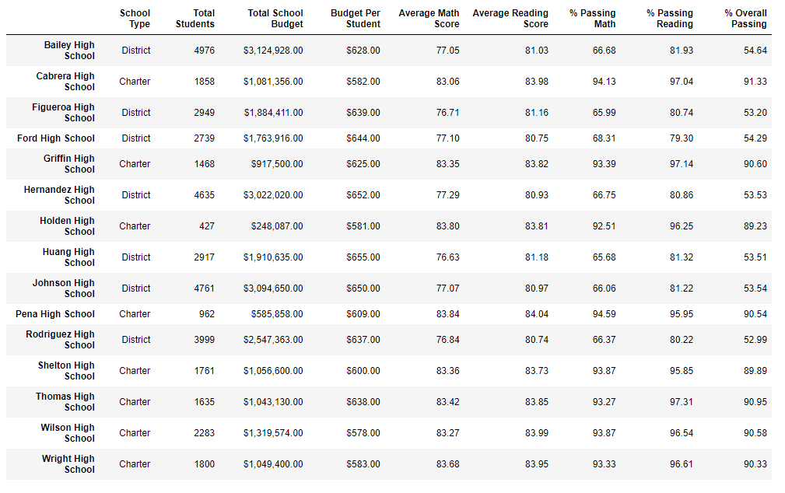](https://user-images.githubusercontent.com/142269763/268736819-cf3f101c-f7c9-409f-9f4b-4ec3026e419a.png)

Highest-Performing Schools (by % Overall Passing):

[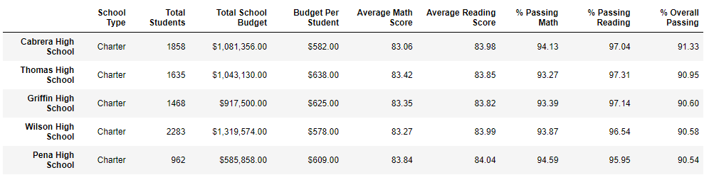](https://user-images.githubusercontent.com/142269763/268516186-466e6800-c583-4826-93c4-8443bcdcdf00.png)

Bottom Performing Schools (By % Overall Passing):

[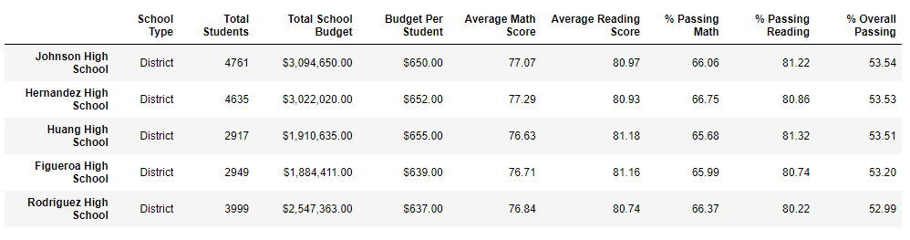](https://user-images.githubusercontent.com/142269763/268516210-32adff96-f094-4eed-997a-be2fcd1611e7.png)

Math Scores by Grade (over 100):

[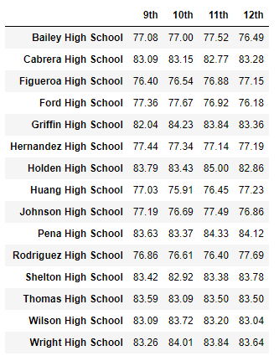](https://user-images.githubusercontent.com/142269763/268741249-4868f434-8243-44a9-bd8d-729a8908fec4.png)

Reading Scores by Grade (over 100):

[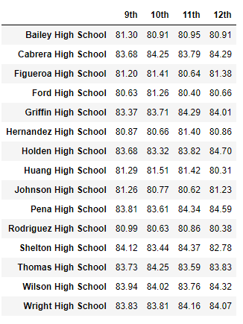](https://user-images.githubusercontent.com/142269763/268741341-dd26054f-0333-4220-b167-8b6292603f9e.png)

School Summary with Spending Ranges Per Student:

[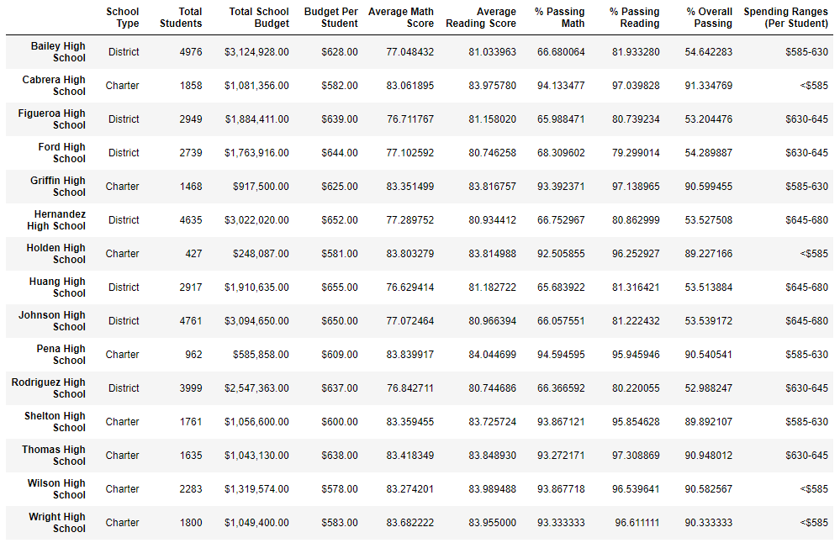](https://user-images.githubusercontent.com/142269763/268742515-0dbd008a-c52f-4df3-ad69-c9dbac7589e2.png)

Scores (over 100) and Passing Rates (%) with Spending Ranges Per Student:

[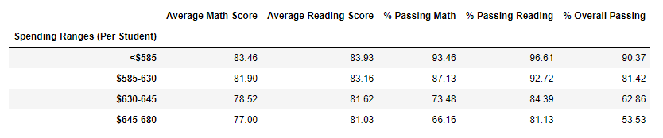](https://user-images.githubusercontent.com/142269763/268743217-b5a496e8-ef64-4ca8-8198-b6db6f6acfd0.png)

School Summary with School Type, Budgets, Scores, Passing Rates, Spending Ranges Per Student and Size Per School:

[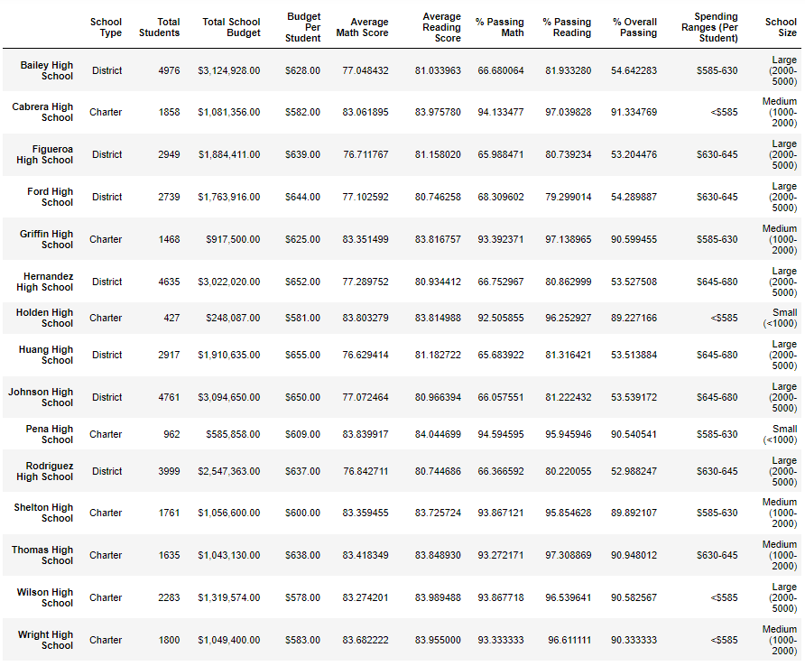](https://user-images.githubusercontent.com/142269763/268743421-5bfac95e-61a2-4714-8602-655d7d8186f5.png)

Average Scores and Passing Rates by School Size:

[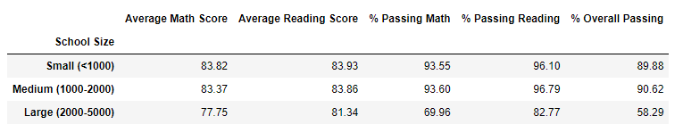](https://user-images.githubusercontent.com/142269763/268744028-02be2fe6-80ce-4603-ae64-0c398d410d88.png)

Average Scores and Passing Rates by School Type:

